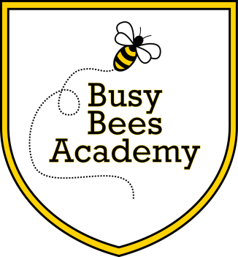

**Busy Bees Academy**

1209 Sycamore St.

Columbus, IN 47201.

(812) 376-4569

Too sick for school?

If your child has the following symptoms, THEY SHOULD **NOT** BE AT SCHOOL:

**FEVER:** Temperature of 100° F or above. Your student may return to school when fever free for 24 hours without medication.

**VOMITING and / or DIARRHEA:** May return if no episodes in the last 24 hours.

**EYE:** Reddened eyes with thick, yellow drainage. May return after being seen by a physician and 24 hours after beginning antibiotic eye drops.

**HEAD LICE:** May return after treatment and checked by the nurse. Bus transportation not available until cleared by the nurse.

**SKIN:** Unknown rashes or open, draining skin lesions.

**PERSISTENT COUGH OR SEVERE PAIN:** If medication is needed at school, it must be registered and stored in the nurse’s office. If the nurse is to administer medicine to a student:

* An order from the physician is required for prescription medications school.
* Medication should be in the original container.
* Written permission from a parent/guardian is required for an over the counter medication to be given at school.

If your child is diagnosed with strep throat, staph infection, mononucleosis, conjunctivitis, fifth’s disease, chicken pox, influenza, or any other communicable condition, please report this to the school nurse as soon as possible.

Thank you for your help in keeping all students healthy!